- First Web Api using .Net core
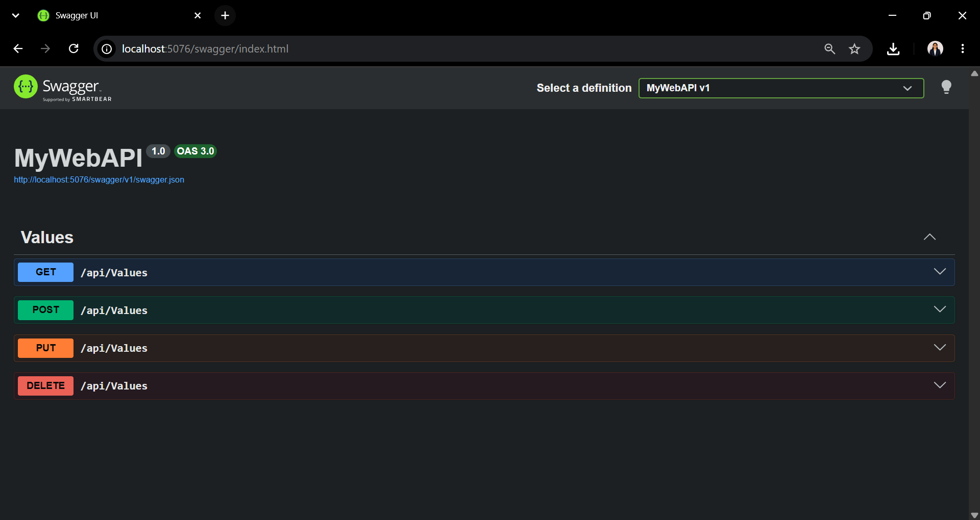
Figure 1: Output of the ASP.NET Core Web API in Swagger UI, showing the available CRUD operations (GET, POST, PUT, DELETE) for the Values API.

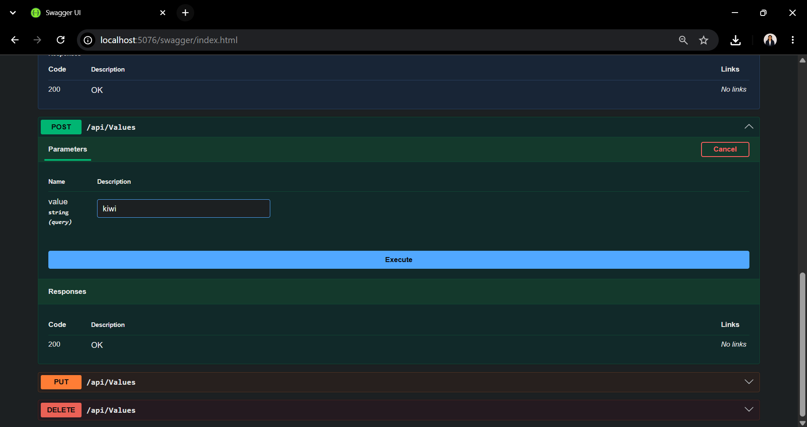
Figure 2: POST request in Swagger UI demonstrating the insertion of a new value ("kiwi") into the Values API.
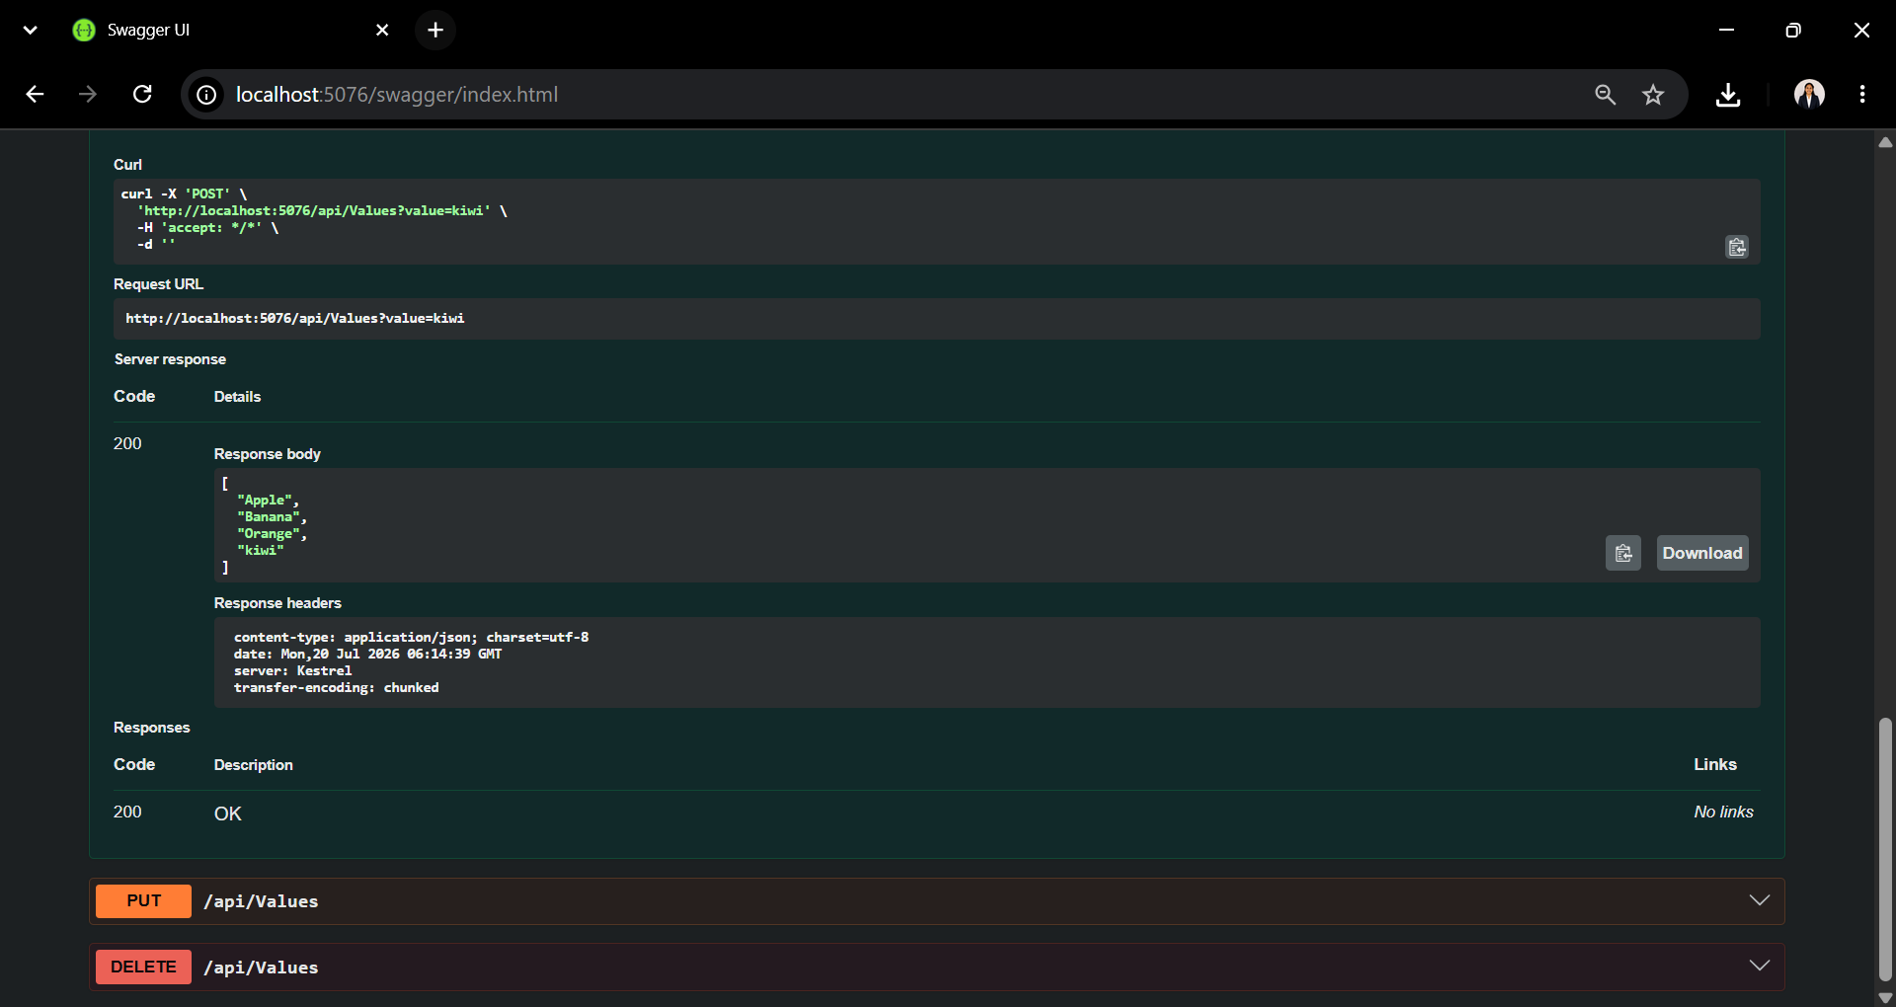
Figure 3: Successful execution of the POST request in Swagger UI, showing the addition of the value "kiwi" to the Values API.

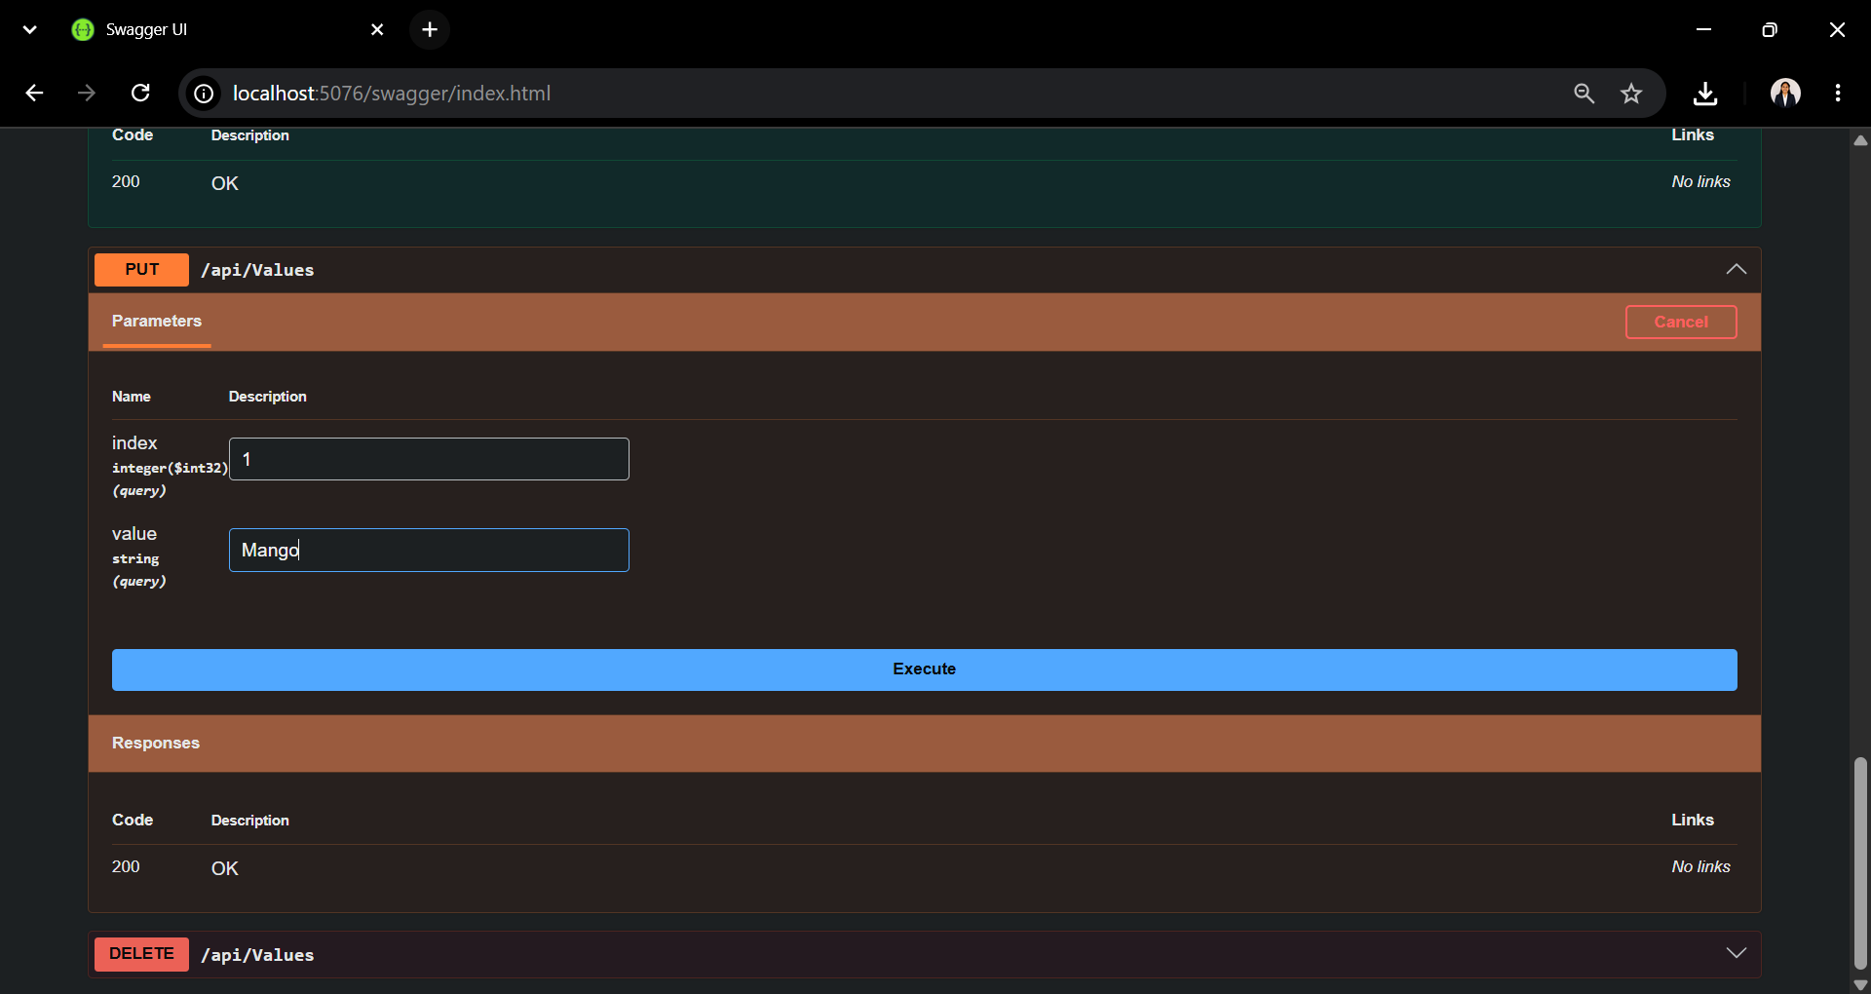
Figure 4: PUT request in Swagger UI demonstrating the update of the value at index 1 to "Mango" in the Values API.

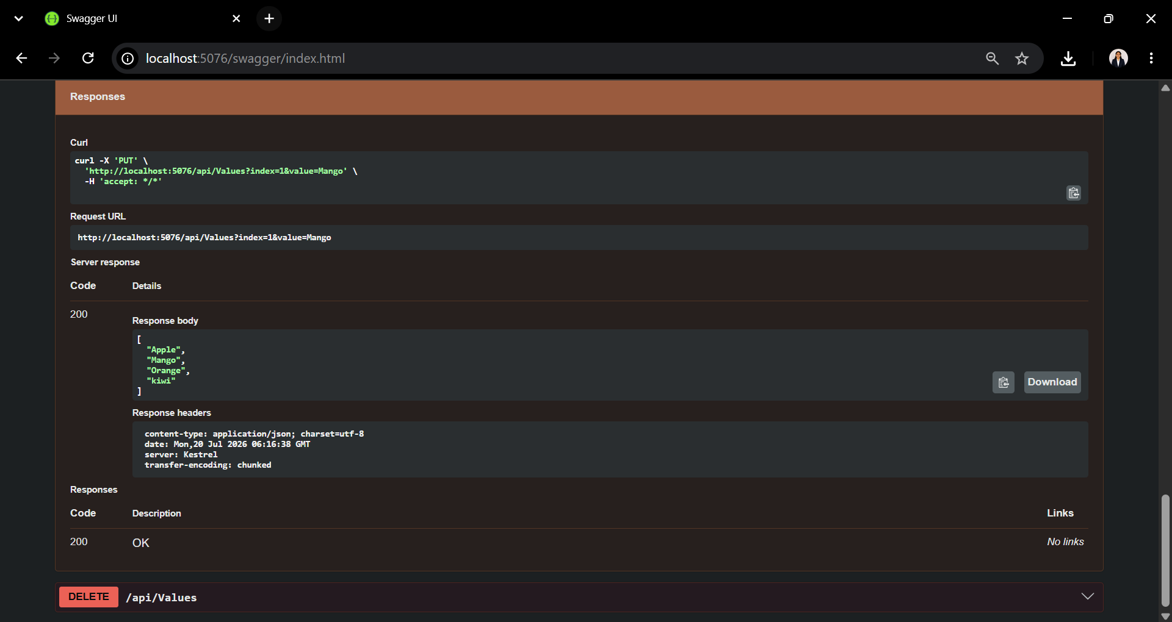
Figure 5: Successful execution of the PUT request in Swagger UI, showing the update of the value at index 1 to "Mango" in the Values API.

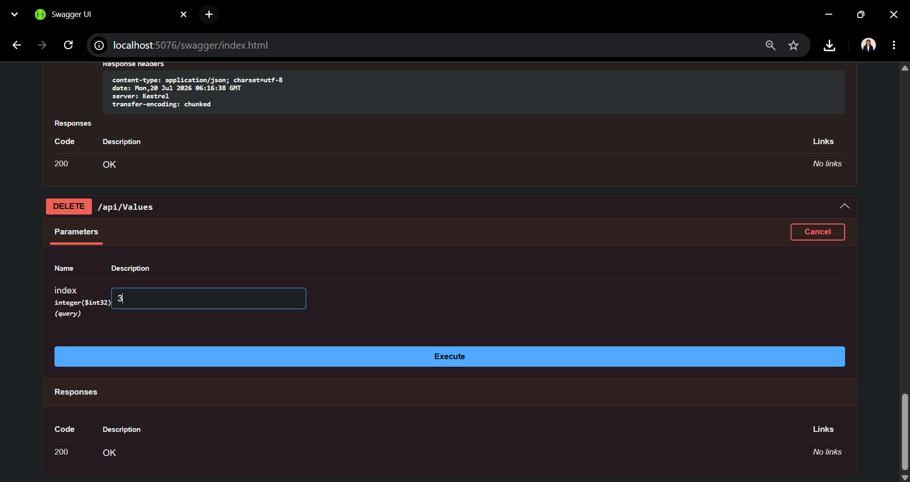
Figure 6: DELETE request in Swagger UI demonstrating the deletion of the value at index 3 from the Values API.

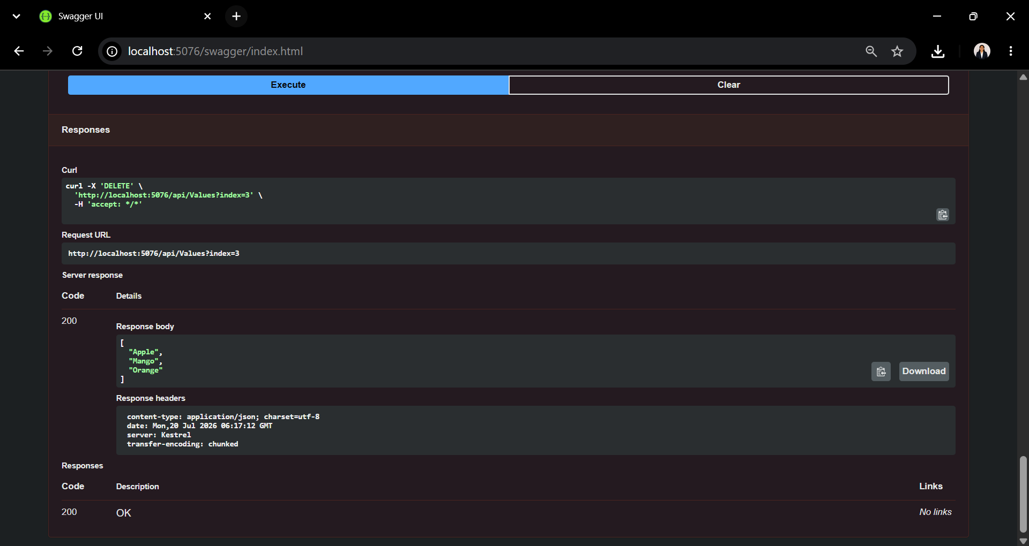
Figure 7: Successful execution of the DELETE request in Swagger UI, showing the deletion of the value at index 3 from the Values API.

